**Group Assignment**

**Group - 2**

**Course:** [**Software Analysis and Design**](https://learn.senecacollege.ca/webapps/blackboard/execute/courseMain?course_id=_681237_1) **(SYD366)**

**Section: ZDD**

**Professor Name: Hesam Akbari**

**Date: 4/6/23**

**Group Members:**

1. Neron Parmar
2. Aarushi Sood
3. Priyanka Khosla

**User Story:**

Christy runs a business of dog grooming. She grooms pets and she loves doing it. She started it from very young age. Moreover, she had all the facilities in her truck that she used to take along with her for grooming the pets. Therefore, she was also as advance as the world. However, she used to forget sometimes on how much amount her client is charged, not only that but also she is not used to keep the records. Thus, she loses the information. As a result, she messes up with keeping the records at last it makes her troubled to file up for the tax refunds. Apart from these, she even keeps pictures and notes but not too frequently keeps the record of it, as she has got information of her clients in those notes and gets it misplaced too often. Therefore, we have created an application in which she can store the data of her client for some basic details as well as she can have the records of payment which can be stored in the database of the application and even the payment’s receipts can be printed. So, basically this would help her to keep the records of her client as well as the details and data of her client secure. Moreover, it would help in keeping count of the amount of income she has made through the saved receipts in her database that will be done after the client has paid her.

**Reasons:**

The main reasons that why your group feels that the user story is important and this idea will be helpful for her is because as Christy does not have the habit of keeping records of her client’s data, also she sometimes forgets the amount she had charged to her clients. Moreover, her clients want their data to be kept secure. Thus, to make all these things possible our application would help her to save the basic details of her client as well as the payment module will help her to keep the data of the client’s payment secure and a record of payment amount can be kept that how much income she had made. At last she has the receipt a module which would help her to print the save for the customer as well as for herself, also save the receipt’s copy electronically in the app. Thus, when it comes to filing for tax refunds it would be easy for her to get the receipts easily. Thus, this app will be very helpful for her to keep the records and details of every thing that she has done in business.

**Use Case description:**

Use Case: Creating the database for saving the basic details of the clients

User Story

As Christy would have plenty of clients and it will be to hard for her to remember as well as she might lose the details written in the hard copies. Therefore, this is to create an application that will have all the records saved in the database of her application

Acceptance Criteria:

1. Can save the entered data of the client.
2. Must be able to fetch the client data after it is saved or created.
3. Must be able to query the client details.

Use Case Descriptions

|  |  |  |  |
| --- | --- | --- | --- |
| Use Case Name | Create Client | | |
| Triggering Event | New client details | | |
| Brief Description | Allows the Owner to record a new client’s information and details. | | |
| Actors | Owner | | |
| Related Use Cases |  | | |
| Preconditions | Owner has opened the Main Menu. | | |
| Post Conditions | Creates clients and saves to the database. | | |
| Flow of activities | Actor | | System |
|  |  | Requests to creates a client | Creates a client and lets to enter the details of them. |
|  |  | Prompts to enter client’s name, address, telephone number and email address (basic details) | Enters the name, address, telephone number and email address. Creates a unique client id, name, address, telephone number and email address. |
|  | 3. | Request to save | Prompts to saves the client details |
|  | 4. | Fetches the client’s data | Gives the fetched data of the client. |
| Exception Conditions | * Owner chooses to cancel adding the customer | | |

User Story

As Christy will have all the data of her client’s details saved in her database. She wants to also save the records of the payments done by her clients so that she can have the data on how much she has charged to a client and how much she has earned.

Acceptance Criteria:

1. It should be able to save the data of the payments done according to the grooming facilities given to the pet.

|  |  |  |  |
| --- | --- | --- | --- |
| Use Case Name | Create Payment | | |
| Triggering Event | Client has to do payment for the grooming given to the pet | | |
| Brief Description | Let Christy to save a payment made by the client according to the grooming done to the pet. | | |
| Actors | Owner | | |
| Related Use Cases |  | | |
| Preconditions | The accounts for the clients have been created to let the payment data enter in it. | | |
| Post Conditions | Payment is created and can now be queried | | |
| Flow of activities | Actor | | System |
|  | 1. | Requests to fetch | Displays a list of clients and prompts for selection. Displays for the service list. |
|  | 2. | Chooses the service from the service list. | Verifies that clients and adds the amount accordingly. |
|  | 3. | Prompts the payment amount | Displays amount charged to the client. Auto generates the date and time for Payment. |
|  | 4. | Confirms the Payment amount | Allows her to confirm the amount and checkout to the next menu. |
|  | 5. | Selects methods for payment | Allows to select on how the client pays her whether its debit/credit, cash or cheque deposit. Also, prompts option for if they want to tip or not. |
|  | 6. | Displays the final payment details | Prompts the payment details in full information of every service provided for the grooming. (Bath charge, Hair trimming etc. shown with individual charge in list and at lasts shows total of all services provided) |
|  | 7. | Chooses to save the payment details. | Saves the payment details. |
| Exception Conditions | * Owner chooses to cancel adding the sale | | |

User Story

As Christy have all the data of the payment saved with her, she would like to get it into the form of receipts for herself as well as for her clients. Moreover, she can also keep the receipts for her future use for getting the data as well as getting the amount of taxes.

Acceptance Criteria:

1. It should be able to fetch the data of payments and the clients and get the receipt data.

Use Case Descriptions

|  |  |  |  |
| --- | --- | --- | --- |
| Use Case Name | Create Receipt | | |
| Triggering Event | Prints the receipt electronically in the mobile device of Christy. | | |
| Brief Description | Lets Christy print the receipt or save the receipt data in her phone it self for her as well as her clients. Thus, she can keep record of all the income done and also can give the receipt for the customers. | | |
| Actors | Owner | | |
| Related Use Cases |  | | |
| Preconditions | The payments done by the client is saved and allows Christy to print the receipt. | | |
| Post Conditions | Receipt has been created and is ready to get printed as well as saved in database of the application. | | |
| Flow of activities | Actor | | System |
|  | 1. | Requests to fetch the data of the payments made by the customers. | Displays a list of payment and the payment details and prompts for selection. Prompts for the confirmation and then select |
|  | 2. | Prints the Receipt to save in the database. | Verifies the payment amount and the client details. Autogenerates the taxes and includes all the taxes. Autogenerates the total calculation. |
|  | 3. | Shows receipt with the final details. | Assigns the date and time  automatically of the system and creates a receipt with final copy. Displays the final reciept |
|  | 4. | Gives the selection for the Saving it | Saves the receipt.  Prompts the menu to print it or to just save it. |
| Exception Conditions | * Christy chooses to print the receipt. * Christy chooses to cancel adding the inventory adjustments. | | |

**Class Diagram: (Supports case description)**

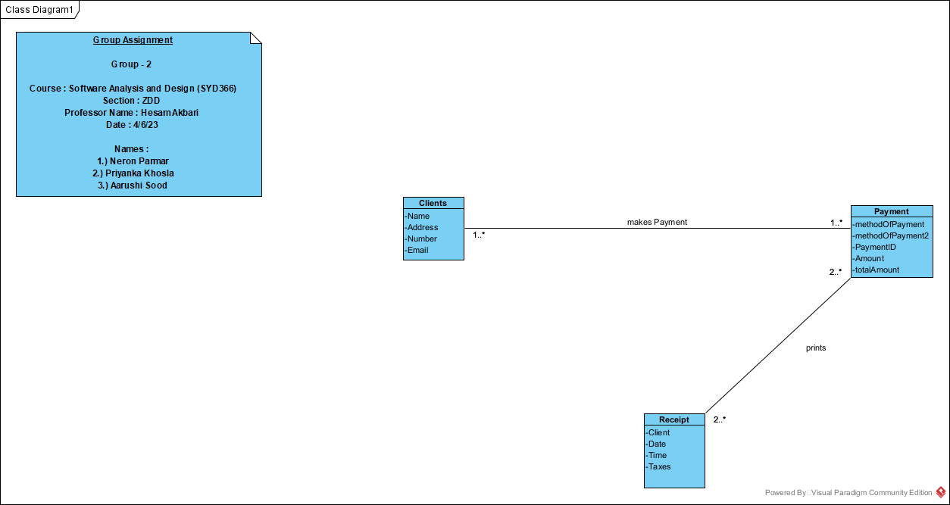

**Sequence Diagram:**

There are three sequence diagram, as we have three cases in our description. Thus, our sequence diagram for each cases are as follows:

**\*Case 1:**

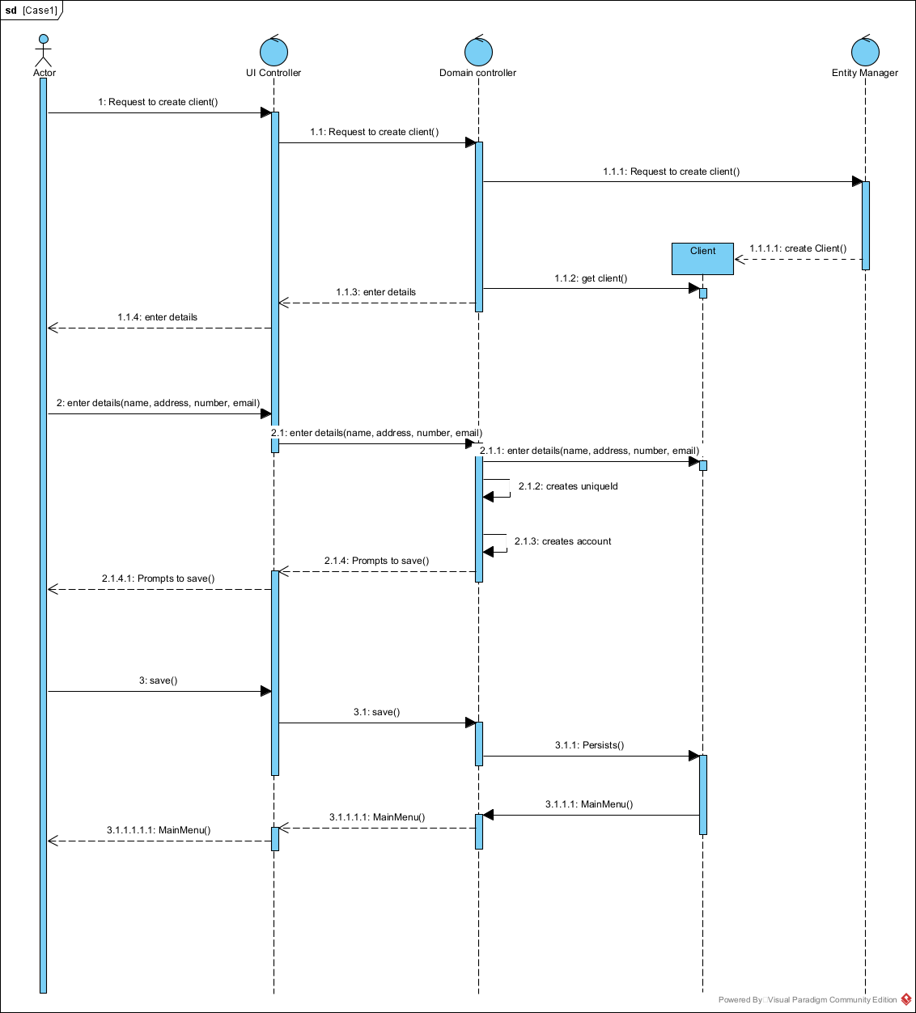

\***Case 2:**

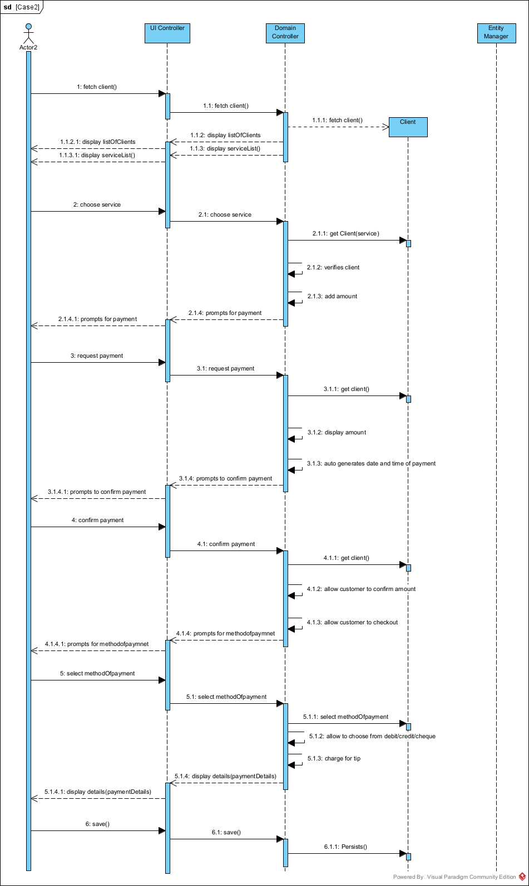

**\*Case 3:**

